**AI ASSISTED CODING LAB ASSIGNMENT 10.2**

**ENROLLMENT NO :**2503A51L21

**BATCH NO:** 19

**NAME:** LUNGHIMPOU KAMEI

TASK1: **AI-Assisted Code Review (Basic Errors)**

* Write python program as shown below.
* Use an AI assistant to review and suggest corrections

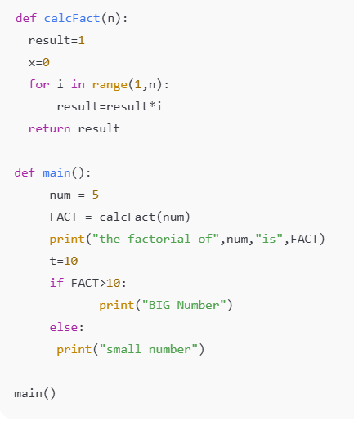

Error Code:

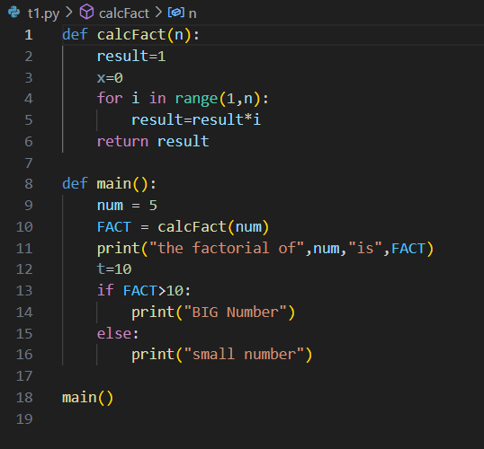

OUTPUT:

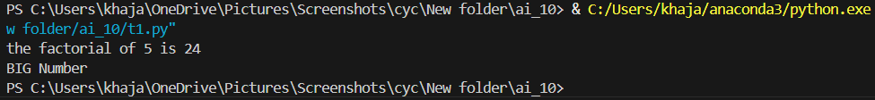

Correct Code:

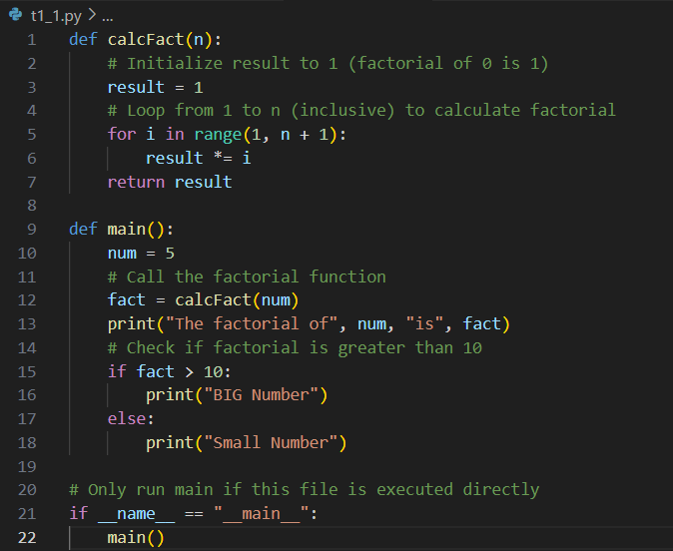

OUTPUT:



OBSERVATION:

In this task, I wrote a Python program that contained basic syntax or logical errors. I then used an AI assistant to review the code and suggest corrections. The AI successfully identified the errors and provided a corrected version of the code, along with explanations. This helped me understand common mistakes and how to fix them efficiently.

TASK2: **Automatic Inline Comments**

* Write the Python code for Fibonacci as shown below and execute.
* Ask AI to improve variable names, add comments, and apply PEP8 formatting (cleaned up).
* Students evaluate which suggestions improve readability most.

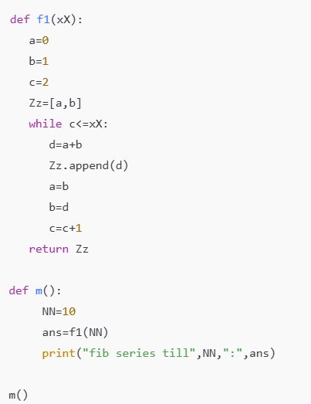

Given Code:

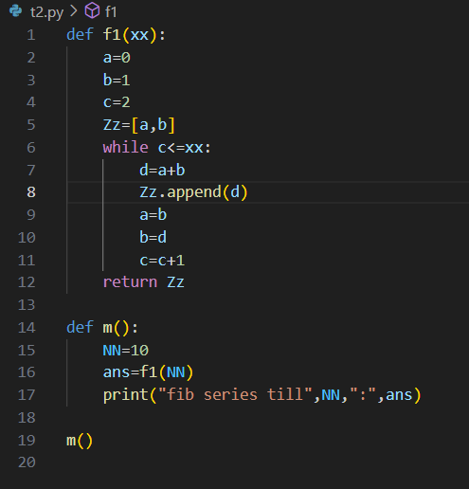

Output:



AI Generated Code:

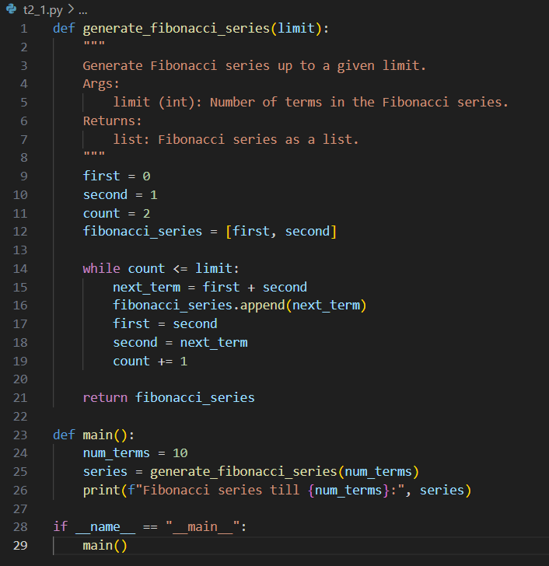

Output:



OBSERVATION:

For this task, I implemented a Python program to generate Fibonacci numbers. After writing the initial code, I asked the AI assistant to improve variable names, add comments, and format the code according to PEP8 guidelines. The AI-generated version was clearer and easier to understand, especially for beginners.

TASK3:

* Write a Python script with 3–4 functions (e.g., calculator: add, subtract, multiply, divide).
* Incorporate manual **docstring** in code with NumPy Style
* Use AI assistance to generate a module-level docstring + individual function docstrings.
* Compare the AI-generated docstring with your manually written one

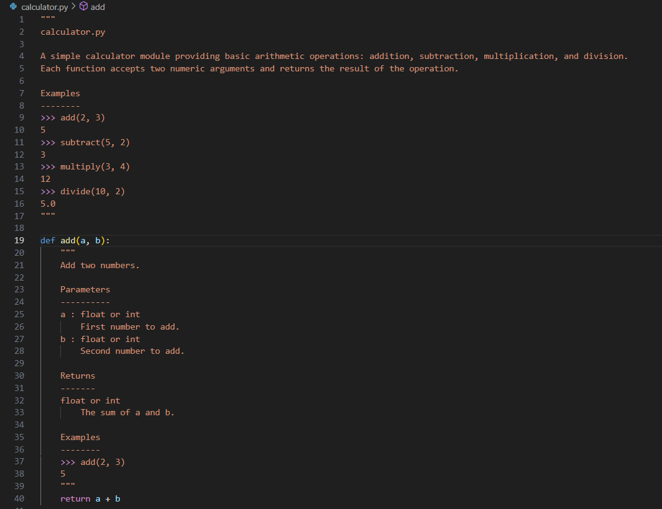

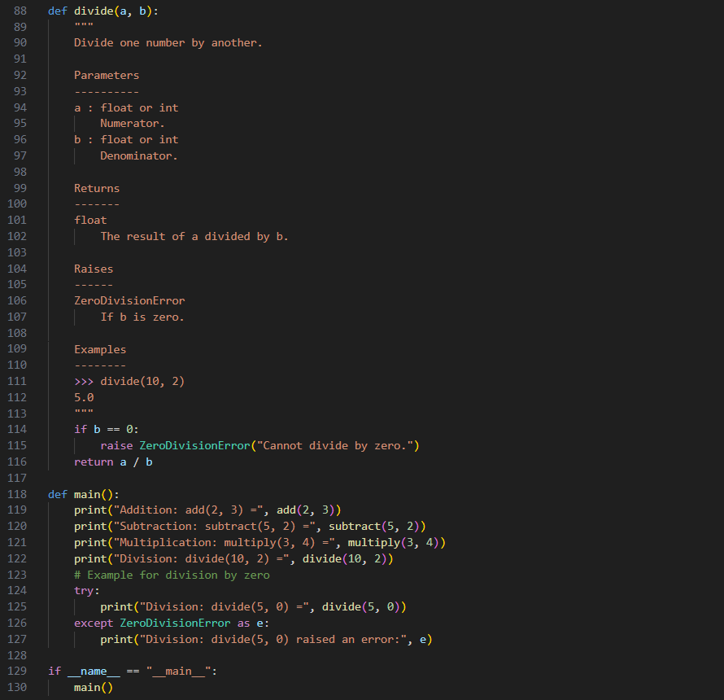

OUTPUT:

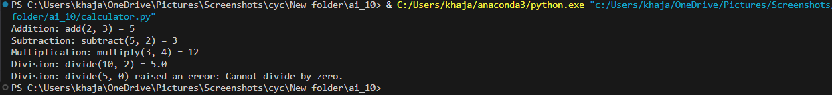

OBSERVATION:

In this task, I created a Python script containing multiple functions such as add, subtract, multiply, and divide. I manually wrote docstrings using the NumPy style format to describe each function’s purpose and parameters. Then, I asked the AI to generate its own module-level and function-level docstrings.